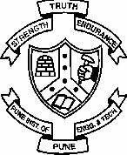College of Engineering, Pune

**(An Autonomous Institute of Government of Maharashtra)**

Applied Science Department

Tel: 020-25507034 Fax: 020-25507219

**CT16002 – Biology for Engineers**

**UNIT I: Biomolecules and Biopolymers**

-----------------------------------------------------------------------------------------------

Structure and Function: Organic and inorganic molecules; Unique Properties of Carbon; Carbohydrates, Amino Acids and proteins, Lipids, Nucleic Acids, Vitamins and Minerals; The Rise of Living Systems.

**1) BIOPOLYMERS & MACROMOLECULES**

A living organism’s body is built of and run by thousands of different types of molecules. As these are made chiefly by the living organisms they are known as biomolecules. Biomolecules have distinct properties and functions responsible for their selection and continuation in the course of evolution.

Many of the small molecules with low molecular weight, simple structure and high solubility are known as **micromolecules** (or monomers e.g. water, mineral, simple sugars, nucleotide etc.) form the building units for larger **macromolecules** (or polymers.e.g. protein, lipids etc.). The biomolecules are classified into organic and inorganic types based on their composition.

Thus, all cells are made up of biomolecules, these are organized in physico -chemical organizations and in isolation they do not have living characteristics. Biomolecules produce, maintain and perpetuate the living state and are continuously transformed i .e. synthesized and broken down.

Water, minerals and gases are important groups of inorganic bimolecules while lipids, carbohydrates, proteins and nucleic acids are the four important classes of organic compounds.

**WATER**

# Physical & Chemical Properties of Water:

* Water is cohesive & adhesive
* Water has high specific heat
* Water has high thermal conductivity
* Water has high boiling point
* Water is good evaporative coolant
* Water has high freezing point and is less dense as a solid than liquid In the biological rea ctions, two important features are observed,
* **polarity** (+ ve charge for H and – ve for O extend polarity to water molecule; water molecules form cluster around electrically charged molecules like PO 4 or COOH, that are

water soluble hence known as **hydrophilic** while water does not react with non charged molecules like lipids that are insoluble known as **hydrophobic**) and

* **ionization ability** (water molecule dissociates to form H and OH ions)

# Significance of water in living system

* Life has doubtless origin from t he water.
* Water is the most abundant substance in living system making up more than 70% of the weight for most of the living organisms.
* Water provides liquid medium for colloidal protoplasm for chemical reactions and transport mechanism in the cell.
* The water molecule and its ionization products, H and OH influence the structure, properties and self assembly of all cellular components.
* Aqueous solutions of weak acids & bases with their salts act as buffer in pH change in biological system. It facilitates chemical reactions in the cells.
* The non covalent interactions responsible for the strength & specificity of biomolecules are decisively influenced by the solvent property of water. It is known as Universal solvent for most of the organic & inorganic molec ules.
* It absorbs heat and maintains body temperature.
* In green plants, it is a source for H + ve ions as a source of energy.
* Removal of waste material thus helps in maintaining **homeostasis**

# MINERALS

Minerals are the nutrients required especially for the g rowth of plants that are absorbed from the soil. Some of these minerals are required in larger quantity and some in trace levels for the plant growth. Accordingly they are known as **micro** or **macronutrients** respectively. The role of some minerals in the cell metabolism is as follows,

|  |  |  |  |  |  |  |
| --- | --- | --- | --- | --- | --- | --- |
| **Mineral** | **Function** |  | **Mineral** | **Function** |  | |
| **N, S** | Synthesis of | Amino acids, | **P** | Present in | compounds | like |

proteins

**K, Na** Constituents of Body fluids, nerve cells, blood plasma

phospholipids, ATP, nucleotides etc.

**Ca** Plays significant role in Blood coagulation & cell wall formation, propulsion of nerve impulses

**Fe** Formation of haemoglobin **Mg** Formation of chlorophyll,

enzymes, structural integrity of ribosomes

**I** Functioning of thyroid glands **Cu, Mo** Activation of enzymes

Ions are required to maintain osmotic concentration of cellular as well as extra cellular fluids.

**Gasses** are significant for the basic cellular processes.

|  |  |
| --- | --- |
| **Gas** | **Function** |
| **O2** | Essential for respiration for all aerobic bacteria, combustion process,  photosynthesis byproduct |
| **N2** | Constituents of proteins, nucleic acid, fixation & release of nitrogen by  bacteria for plants |
| **CO2** | Used in photosynthesis, excess is dissolved in water |

**Carbohydrates** –These are hydrates of carbon made up of C, H, O

**Reducing sugars** – Sugars with free aldehyde / ketone group

**Non- reducing sugars** - e.g. aldehyde region of glucose reacting with ketone region of fructose – form glycosidic bond – non – reducing sugar as free aldehyde / ketone groups are masked.

Aldoses: Glucose, Ribose, Deoxiribose, Mannose, Galactose etc. Ketoses: Fructose, Ribulose, Xylulose etc.

According to number of monomers present in carbohydrate molecule Monosaccharide**: Water soluble**

* Trioses (Dihydroxy acetone, glyceraldehydes)
* Tetroses (Threose, Erythrose)
* Pentoses (Ribose, Deoxyribose, Xylose, Ribulose, Arabinose)
* Hexoses (Glucose – also called blood sugar, grape sugar and Dextrose can be polymerized in to glycogen in animals and starch in plants; Fructose – Fruit sugar; Galactose, Mannose)
* Heptose (Sedoheptulose)

**Oligosaccharides** : 2-9 monomers

* Disccharides (Maltose, Sucrose, lactose etc)
* Trisaccharides (Raphinose, Pectin, Innulin)
* Polysaccharides (Starch, Cellulose, Glycogen, Chitin, Agar)

**Homo-polymers**: All the monomers same in given polysaccharides (Star ch, Hemicellulose, Cellulose, Glycogen)

**Hetero-polymers**: Two or more monomers in given polysaccharides (Agar, Chitin)

# Monomers are linked by glycosidic bond during polymerization Types & Function of Polysaccharides:

Storage polysaccharides: *Starch*, *inulin* stored in roots, tubers of plants; *Glycogen*: In animals and bacteria

*Inulin* is the smallest polysaccharide: not metabolized in human body filtered through kidney.  used in kidney testing.

**Structural polysaccharides:** *Cellulose, Hemicellulose, Pectin* – (in plants), Chitin (plant fibres & animal exoskeleton like insects, spiders, crabs etc.)

*Chondrin sulphate* in cartilage, tendon ligament

*Hyaluronic acid* – (glucoronic a.+ acetyl glucosamine) cementing subs. between animal cells. In diff body fluid – vitreous humor of eye,

sinusoidal fluid CSF e.g. *Keratan Sulphate* in cornea, skin, cartilage, bone, hair, nail

**Mucopolysaccharide** – slimy substances e. g. *Hyaluronic acid*

Agar – used in culture media, medicine, capsules and chromatography Algin –used in Ice creams, cosmetics.

Carrageenin – used as a emulsifier, clearing agent – fruit juice. Funori –used as adhesilve in hair curling

Heparin – used in blood bank as blood anti -coagulant Husk of *Plantago ovata* – used as purgative / laxative

Aloegel – used as inflammation - relief, in hand lotion, shampoo, hair conditioner, sunscreen lotion.

**PROTEINS:**

Proteins make up more than 50 % of the dry mass of animals and bacteria and perform important functions in living organisms. They contain the elements carbon, o xygen, hydrogen, nitrogen and usually sulfur that makes a monomer of protein i.e. amino acid. All organisms contain 20 common amino acids as biological molecules.

Essential amino acids: cannot be synthesized by animals, so must be taken in diet. In man such amino acids are 8, in other animals are 7.

Non-Essential Amino acids: Can be synthesized by animals, so may not be taken in diet

Each amino acid (AA) has a carboxyl group ( -COOH), amino group ( -NH2) and a hydrogen atom bounded to a central carbon atom. The sequence of amino acids (linked by peptide bond) determines the overall shape and properties of proteins. Depending on number of amino acids in a chain oligopeptide (1 -10 AA), Polypeptides (11 -50 AA) and protein (>50 AA).

Various categories made for the classification of proteins based on the composition, structure etc. are as follows;

# Structural organization of proteins:

**PrimaryProteins** : two dimensional, simple chain of AA with peptide (covalent) bond e.g. Insulin

**Secondary Proteins** : Various functional groups exposed on outer surface interact with hydrogen bonds

* - helix – e.g. keratin, hair, fur, clans, hooves
* – pleated – B. keratin of feathers, silk fibroin
* Collagen helix – 3  – helices coiled around one another

**Tertiary Proteins**: Additional bonds between functional groups, twisting of secondary protein, weak covalent and high energy disulphide bonds are formed e.g. Myoglobin **Quaternary** P**roteins**: Formed as a result of 2 -more

polypeptide chain and have specific orientation

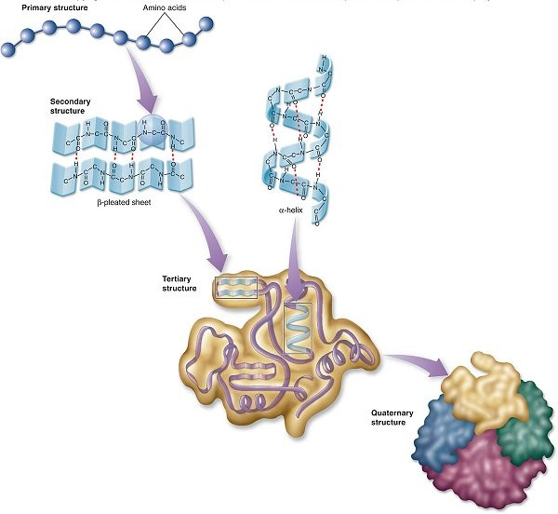

# Types of proteins according to structure:

**Fibrous** – collagen fibres, keratin, elastin, fibrin, fibroin, actin, myosin, bl. clot.

**Globular** – glutelin, protemine, globulin, albumin, glutenin, orygemin.

**Intermediate** – (myosin), fibrinogen.

# Types of proteins according to chemical nature

**Simple** – only a.a. Albumin, globulin, protanine, fish, prolamine (corn, pl, wheat), histone (corn, wheat), glutelin (glutenin), keratin.

**Conjugated** – protein + non protein (prosthetic group) e.g. **Nucleoprotein** (nucleic acid), **chromoprotein** (Hb, cytochrome), **metallo** (with metals Zn, Fe ), **lipoprotein** , **glycoprotein** etc.

# Properties of proteins:

* Number: According to length,, number & types of polypeptides – thousands of proteins
* Specificity: High specificity in the individual but s hared with related species or group
* Molecular weight – ACTH (4500 daltons) to Pyruvate Dehydrogenase (4,600,000 daltons)
* Solubility: Some are insoluble due to large size, many form colloidal solution with water
* Amphoteric nature: Show both acidic & basic p roperties.
* Electrical reaction: Isoelectric point at which pH is neutral (Curdling of milk at pH 4.7 due to isoelectric point at acidic pH 4.7)
* Denaturation: Permanent or temporary loss of three dimensional structure caused due to UV, heat, strong acid & a lkali, high salt concentration; within limit renaturation occur.

# Role of protein:

|  |  |  |  |  |  |  |  |
| --- | --- | --- | --- | --- | --- | --- | --- |
| **Type of protein** | **Example** | | | **Function** | | | |
| Enzymes | Amylase | | | Converts starch into sugar | | | |
| Structural | Keratin, Collagen  Haemoglobin | | | Hair, wool, nail, horn, hoofs, tendons, cartilage  Blood clotting | | | |
| Hormones | Insulin, glucagons | | | Regulate glucose metabolism | | | |
| Contractile | Actin, myosin | | | Contractile filaments in muscle, cilia  & flagella (in lower organisms) | | | |
| Amphoteric | All proteins | | | Maintain acid-base equilibrium | | | |
| Storage | Ferritin, albumin  Casin | | | Stores iron in spleen & egg yolk  Milk | | | |
| Transport | Haemoglobin  Serum albumin | | | Carried oxygen in blood  Carries fatty acid in blood | | | |
| Energy | All proteins | | | Provides energy stored in peptide  bonds | | | |
| Metaloprotein | Cytochrome | | | Electron transport | | | |
| Receptor | Adrenalin | | | Conduction of nerve stimulus | | | |
| Nucleoprotein | Histones  histone | & | non- | Stabilization of DNA coiling | | | |
| Immunological | Antibodies | | | Forms  proteins | complexes | with | foreign |
| Toxins | Venum (Neurotoxin) | | | Blocks the nerve function | | | |

Proteins are masterpieces of molecular engineering and they are tailored to their functions by millions of years of natural selection.

**LIPIDS:**

Lipids are the organic compounds that share a distinguishing property of non polarity and so do not dissolve in water. They mostly contain carbon and hydrogen with very small portion of oxygen compare to carbohydrates. Some of them also incorporate phospho rus and nitrogen. Basically they are polymers of fatty acids & glycerol.

As lipids are insoluble in water they are vital components of the membrane that separate living cells from each other and their surrounding.

Lipids offer unique way to store energy as they possess very high proportion of energy rich carbon-hydrogen bonds in a concentrated form within the cells. They contain six times more energy than the carbohydrates and have become increasingly important as food reserves for organisms. (e.g. migra tory birds).

**Fatty Acids**: Simplest form of lipids consisting of a long hydrocarbon chain (non polar hydrophobic) with a carboxyl group at the end (which is hydrophilic). Because of this characteristic orientation, fatty acids significantly contribute in th e structure of cell wall.

**Fats & Oils**: These are the energy store reserves for the plant & animal cells. Fats are formed by the condensation of fatty acid molecules and are characteristically non polar. They are classified into **saturated** (butter, coconut oil) which are solid at room temperature and without double bond and **unsaturated** (from olive, corn, safflower, peanut etc.) which are liquid at room temperature and with double bond. Usually, animals use saturated fatty acids against the plants with unsatu rated fatty acids.

**Phospholipids**: These are similar to fats except one or two fatty acids are replaced by phosphate group which in turn are linked to nitrogen containing group.

**Steroids**: They differ from lipids in structure but insoluble in water. Cholesterol is most commonly known steroid forming essential component of animal cell membrane. It also served as a raw material for the production of vitamin D and steroid hormones.

In general the steroids carry chemical messages between the cells.

# Properties:

* Saturated & unsaturated
* Insoluble in water and soluble in organic solvents like alcohol
* Low specific gravity hence float on water
* On hydrolysis give fatty acids and glycerol
* Neutral fat s or triglycerides are colour less, odder less, taste less
* Rancidity: Naturally occurring unsaturated fats undergo partial hydrolysis by the action of enzyme lipase. Oxidation at double bond produces aldehydes and carboxylic acids. This develops foul test and odder to the fats. **Types of Lipids –**

1. **Simple Lipids** – These are neutral or true fats. Solid at room temperature, on hydrolysis give three faty acids and one glycerol e.g. waxes

R C O R  esters of fatty acids with different alcohols.

e.g. tripalmitin, diplamitin are hard fats, solid at room temp.

# Compound / Conjugated lipids –

**Phospolipids** – Cephalin – act as insulation for nerves

Lecithin – cell permeability

**Glycolipds** – Cerebrosides – brain cells – cell mem. gangliosides – grey matter.

Sphingomyelins –in myelin sheath. Sphingosine  amino alcohol.

**Lipoproteins** – found in milk, egg yolk, blood plasma, tissues, cell surfaces.

Cutin – from cuticle.

Suberin – due to it cell wall impermeable to H 2O. Chromolipds – e.g. carotenoids.

1. **Derived Lipids** –Formed from hydrolysis of simple & comp. lipids, Include f.a., steroids, prostaglandins, terpenes.

**Prostaglandins** – Hormone – like unsaturated fatty acids / local hormones, present in amniotic and tissue fluid

* + Circulate in blood
  + Cause acid production in stomach
  + Stimulate contraction of smooth muscles.

**Steroids** – solid wax like alcohols e.g. ergosterol – yeast. Cholesterol - animal cell mem., blood, bite. When bl. level of chole. rises – Cholesterol and its esters form bond with fats secreted by endothelium of arteries. And thus deposited on wall of arteries.

It is precursor for hormone progesterone, testosterone, cortisol, estradiol, androsteron Produces bile salts, vitamin D by action o f U V rays of sunlight.

* React with protein in nucleus
* Trigger changes in gene expression and metabolism

# Role of lipids:

* Reserved food: In plants oilseeds like groundnuts, mustard, coconut are the stores of fats. Animals contain adipocytes which are the ce lls containing the fat droplets as stored food.
* Structural component: Phospholipids, glycolipids and sterols are the structural components of the cell membranes.
* Synthesis: Take part in the synthesis of steroids, hormones, Vit D etc.
* Energy source: Rich so urce of energy. 9.3 kcal/ gram
* Insulation: Provide electrical and thermal insulation. Deposited below the skin and around the internal organs to lessen the heat loss. Also work as shock absorbers.
* Solvent: Fats are the solvents for fat soluble vitamins like A, D, K, E.
* Waxes are water proof agents e.g. fur, feathers, insect exoskeleton, bee wax, ear wax (cerumen), skin wax (sebum), paraffin wax & plant waxes

**NUCLEIC ACIDS :**

1streported by Friedrich Miescher. from pus cells nuclei. Called them nuclein. Altman called

N.A. Feulgen developed staining tech. of N.A. with fusch.

# DNA – Deoxyribo nucleic acid

Made up of three components –

1. Deoxyribose sugar – (pentagonal shape with 5 C atoms)
2. Nitrogen containing bases – Purine – Adenine (A), Guanine (G).

Pyrimidine – Cytosine (C), Thymine (T)

# Pentose suger + N base  nucleoside

**Glycosidic bond** between 1st C of sugar and nitrogen at 3 rd position in pyrimidine base and 9th position in purine base.

1. ) Phosphoric acid –

OH – 3 acid groups.

OH

O P OH

OH

Nucleoside + P group at 5’ position by **phosphor-diester bond**.

# Nucleoside + Phosphate group  nucleotide.

Amount of DNA measured by picogram = 10 -12 g., 1 Pg DNA has 31 cm length. Human cell – contains 5.6 Pg DNA – 174 cm long.

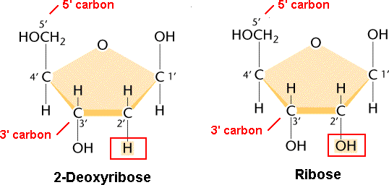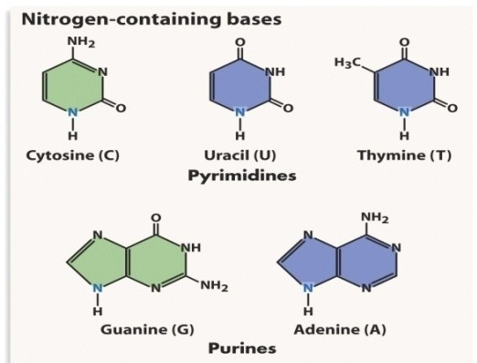

|  |  |  |  |  |  |  |  |  |
| --- | --- | --- | --- | --- | --- | --- | --- | --- |
| Chain of nucleotides – **poly nucleotide chain** |  | | | | | | | |
| 5’  P  ׀ A  ׀ S |  | T |  | S | ׀ |  |  | 3’ |
| ׀  ׀ P G  ׀ S  ׀ |  | C |  | S |  |  | P  P |  |
| ׀ P T |  | C |  |  |  |  |  |  |
| ׀ S |  |  |  | S |  |  |  |  |
| ׀  ׀ P C | C |  |  |  |  |  | P |  |
| ׀ S |  |  | S |  |  |  |  |  |
| ↓  3´ |  |  |  |  |  | P |  |  |

# Characteristics / Properties – DNA

* + It has several thousand Nucleotides.
  + Back bone of it by alternate d sugar and PO 4 gr.
  + Nitrogen bases are inside at right angle to longitudinal axis.
  + PO4 gr. Attached 5 th , 3rd C atom.
  + By phosphodiester bond.
  + 2 chains joined by weak H bond – A = T, G = C specific pairing. H of one base linked to O2 / N 2 of another base.
  + 2 strands anti parallel i.e. 3’, 5’ phosphor link in opp. direction.
  + Pairing specific  2 chain complementary.

i.e. sequence of N2 bases in one chain will decide it on other chain.

* + Diameter of DNA – 20 A
  + **Erwin Chargaff’s rule** – regardless of source - purine, pyrimidine components occur in equal amounts in a DNA mole.

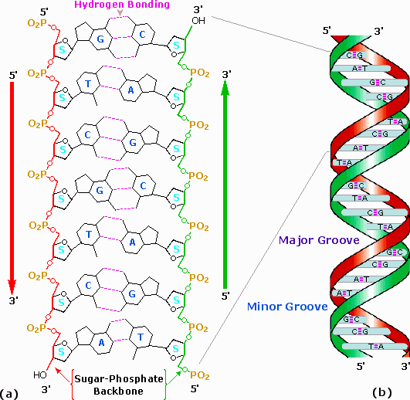

1) A = T, G = C from this it is also seen

2) *A*  *C*  1

*T G*

1. A +G = T + C
2. A + C = G + T but
3. A + T not always G + C necessarily.

**James Waston & Francis Crick –** suggested three dimensional molecular model based on X ray crystallography technique; according to this model DNA comprises of

1. 2 right Handed helices.
2. Each turn has – 10 nitrogen base pairs
3. One spiral each 3.4 A
4. Distance between 2 nitrogen bases 3.4A 

# Denaturation and Renaturation of DNA –

1. If DNA solution heated / exposed to alkaline PH or acidic PH, H bonds break and 2 strands uncoil this is known as **denaturation** or **DNA melting**.
2. If above solution gradually cooled / neutralized – new base pair formation begins, it becomes thermally / chemically stable finally double stranded DNA formed which is called as **renaturation** .

**Linear DNA with** ends free **with histones** (eukaryotes) and circula r DNA 2 ends covalently linked **without histones (** prokaryots).

# Repetitive DNA –

* The part of DNA which contains same sequence of N bases repeated several times in tandem ( one behind another)

e.g. A A T C G G A A T C G G A A T C G G

* It occurs specifically near telomeres (ends), centromeres,
* Area with long sequence of repetitive DNA is called satellite DNA as it separates out during density gradient ultra centrifugation.
* Microsatellite DNA  1 – 10 base pairs repeat units

Minisatellit e DNA  11 – 60 base pairs repeat units, it is hypervariable (it is known as VNTR variable Number of Tandom Repeats discovered by Jeffreys et al., specific for each individual therefore used in DNA finger printing.

# Palindromic DNA –

DNA duplex has areas with sequence of nucleotides same reading forward or backward from central axis of symmetry G A C T G C G T C A G

AND MADAM DNA

(Restriction endo -nuclease commonly recognize DNA sequences that are palindromes.

# RNA – Ribo Nucleic Acid –

It is also made up of three components;

1. Ribose sugar – Pentose sugar
2. Nitrogen containing bases – **Purine** – Adenine, Guanine & **Pyrimidine** – Cytosine, Uracil. Sugar + N. B.  Nucleoside

**Genetic** in some pl. viruses TMV yellow MV animal viruses – influenza, poliomyelitis, HIV; Animal, Plant viruses  single stranded

Reovirus of some plant  Double stranded.

# Non- genetic RNA –

Mainly in nucleolus, cytoplasm, ribosome, mitochondria, chloroplast, in association with chromo.

Found both in pro & eukaryots

Synthesis in N on one of the DNA strand by transcription. Thus carries genetic inf. from DNA.

**Structure** – Single stranded. Hence does not follow Chargaff’s rule.

# Types – three types of RNA - all are synthesized in nucleus

1. **m – RNA / messenger / template** : linear, longest molecule with 900 – 1500 nucleotides

Function: To carry genetic information in the form of codons from DNA to site of protein synthesis i.e. ribosomes.

1. **r – RNA** / ribosomal RNA – folded. Function:

* Proper orientation of m RNA
* Formation of ribosomal complex by the attachment of smaller & larger subunit and further ribosomal complex with m RNA
* relese of t RNA from ribosome complex after transfer of AA to polypeptide chain

1. **t - RNA / transfer RNA/ soluble RNA** (can’t be precipitated by ultracentrifugation) Structure: According to shape two models are explained viz. clover leaf and hair pin Function:

* To bring AA at the site of protein synthesis
* Transfer of AA to polypeptide chain

